How to Reset your Password Using ADSelfService WebPortal:
(You must enroll first before using this process)
First open your web browser and go to this site: https://myid.indianriverschools.org
Next Click on the titled “Reset Password”

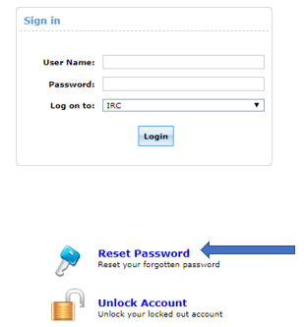

On the next screen you will be asked to provide your “Username”. Type it into the text box next to “Enter Username” and click the green “Continue” button.

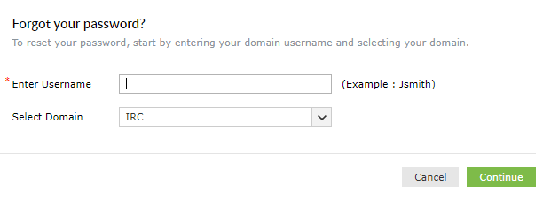

You will then be asked to select which verification method you would like to use to verify your identity. For this demonstration I will select “email verification” and then click the green “Continue” button. (If you were to choose SMS Verification and hit the green “Continue” button, you would receive a text message with a verification code. On the next screen you would type the verification code in the text box and press the green “Continue” button)

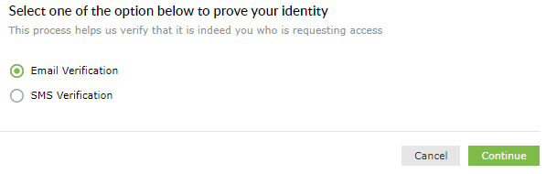

On the next screen you will be asked to select your email address that you want to send the verification code to. Click the drop-down arrow, then click on the email address you would like to use and finally click the green “Continue” button.

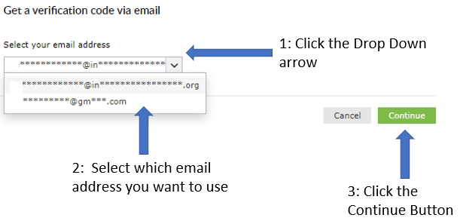

Now check the email account that you sent the verification code to. You should have received an email from Password.Portal@indianriverschools.org with the subject Password Reset Confirmation. Open that email to get your verification code and type it into the textbox then press the green “Continue” button.

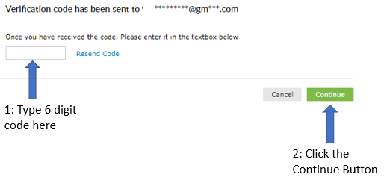

On the next screen you will be able to change your password. Your new password must meet the following criteria: Must be at least eight characters long, must have a capital letter, must have a lower-case letter, and must contain at least one numerical character. Optionally you can use a symbol.

